The Situation and Underlying Reasons of Chinese College Student Driver Licensing

Methods

Materials
An online survey was administered via WJX (www.wjx.com), an internet-based application. A detailed questionnaire was formulated to investigate a multitude of factors related to an individual’s decision to obtain a driver’s license or not, along with the motivations underlying these choices. The benefit of this approach is that it could get a comprehensive understanding of the participants' views on the matter of obtaining a driver's license.
The primary considerations for forgoing a driver’s license were gleaned from the work by Delbosc and Currie (2013) about…不要用原名请rephrase, which contained two parts: primary and secondary reasons for the non-acquisition of a driver’s license. To make the issues more adapted to the latest societal conditions (citation), researchers added the following questions: 这三个东西语法形式保持一致，like都是名词词组or都是句子
Underage. (Driving is illegal until age 18 in China)
Studying in a different place, without the conditions to drive. (It is quite common to study in a different place in China)
Autonomous driving will become mainstream, making learning to drive pointless. (Autonomous driving may become a reality someday)
In correspondence with this, the issues about obtaining a driving license were originally created by researchers. Please refer to the chart for specific details.
图表只起辅助作用，必须要详细描述问卷内容图片内容
问卷描述顺序有问题，应该从背景信息、是否有驾照、再问到reasons

Figure 1
Illustration of the questionnaire structure
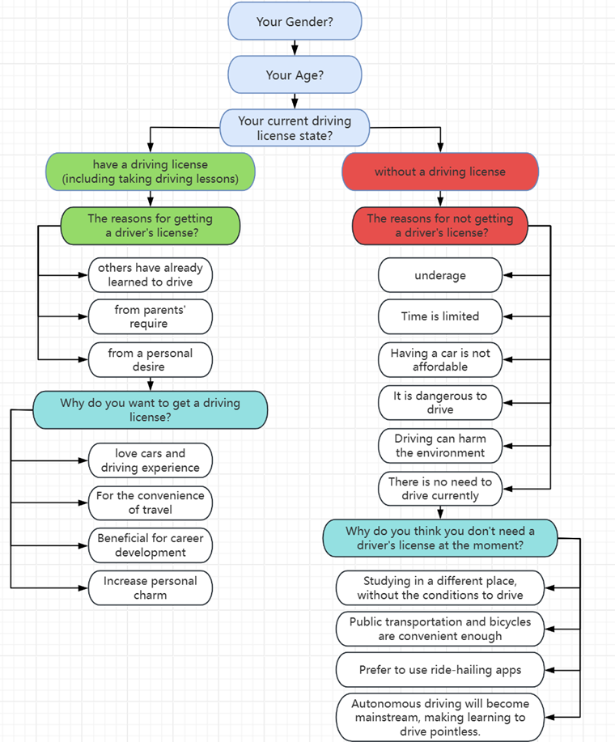
Note. An option for voluntary interviews was provided at the end of the questionnaire to gather deeper insights.
To obtain the participants’ interpretations and understanding of a certain respect, as well as to further supplement the reasons for obtaining and not obtaining a driving license, voluntary interviews were arranged.
The interview questions consisted of the following four questions:
- What was your reason for (not) obtaining a driver’s license? Please provide a specific example. 第一二问冲突，应该写一起
- What are your reasons for not needing a driver’s license? Please at least mention the two most significant aspects that have an impact on you.
- How do you choose what travel mode to take (e.g., drive, walk, and public transport)?
- Will how you travel today change over the next 5, 10, or 20 years? Please talk about your views on the future of autonomous driving.
The last two were adapted from < Using discussion forums to explore attitudes toward cars and licensing among young Australians> (Delbosc & Currie, 2014).

Participants 这部分放最前面
The participants were 303 undergraduate students from Chinese universities. Informed consent was obtained from all participants before data collection. Most of the participants came from Beijing (190). There were 215 males and 88 females in the sample and their ages ranged from 17 to 24 (mean = 18.4), with most participants being 18 years old.
The voluntary interviewees account for 10% of the total participants说具体多少人. Among them, 12 were valid, and all were from Tsinghua University.

Procedure
Mass online questionnaires were distributed via WeChat to undergraduate students, inviting them to participate in the survey. Participants chose the option that best suited them for each question based on their actual situation, by which we could get the data on the choice of each question. After the data were collected, data analysis software was used to analyze the proportion of each selection. The discussion section of this research was based on the data collected.
At the same time, structured interviews were conducted. Initially, researchers posed open-ended questions to elicit general ideas. Then the interviewees were asked a few questions with prompts, and these original questions were adjusted to suit different interviewees. For example, the unlicensed participants were not asked about question 1).
The respondents’ answers were recorded and categorized based on different attitudes. The value of different responses was evaluated and those representative ones were selected to provide a summary and supplement to the questionnaire results.
语言流畅，结构清晰，注意到了一些细节
materials缺少对问卷题型的描述，procedure缺少被访者是如何从答问卷的人里筛出来的描述，缺少数据分析方法
问卷设计基础？summary？形式？分值还是选项？
如何分析？
8

Group 2
Members:
汤岳涵 2024010743
吕研 2024010941
张芝源 2024010701
吴宇同 2024010940

